DM-G35 Drone Motor
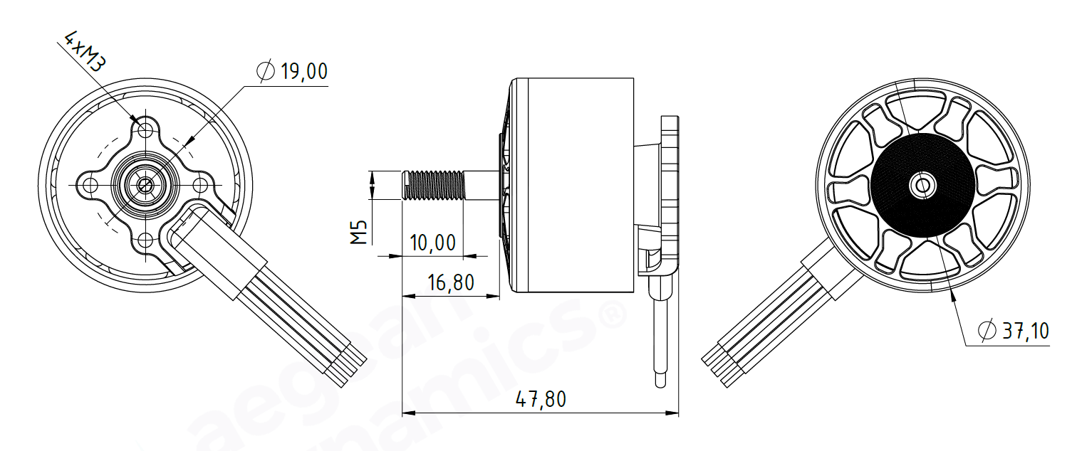
Basic Motor Parameters
Throttle | % | 60
Max. Thrust | kg | 5.1
Recommended Takeoff Weight | kg | 2-2,5
Torque | Nm | 0.37
KV Rating | rpm/V | 900
Bus Voltage | S | 6S
Max. Efficiency | % | 90
Operating Current | A | 23
Rated Speed | rpm | 9500
Propeller Force Efficiency | g/W | 4.3
Electrical Parameters
Number of Phases |  | 3
Number of Poles |  | 14
Terminal Resistance Phase to Phase (±%10) | mΩ | 45
Terminal Inductance Phase to Phase (±%30) | mH | 30
Thermal Data
Ambient Temperature | °C | -40...+85
Max. Winding Temperature | °C | +155
Physical Parameters
Outer Diameter | mm | 37.1
Shaft Diameter | mm | M5
Max. Lenght | mm | 47.8
Weight | gr | 121
Motor Connection
U | Black
V | Black
W | Black
Sensor Connection
N/A | N/A
Connector Articles
Power | N/A
Signal | N/A
Propeller Info (Recommended)
Diameter | 10”
Pitch | 5”

